EE313 Project Design Phase
Wideband amplifier with an automatic gain control
Ömer Faruk Akbay
22102584
"I affirm that I have not given or received any unauthorized help on this report and that this work is my own.”

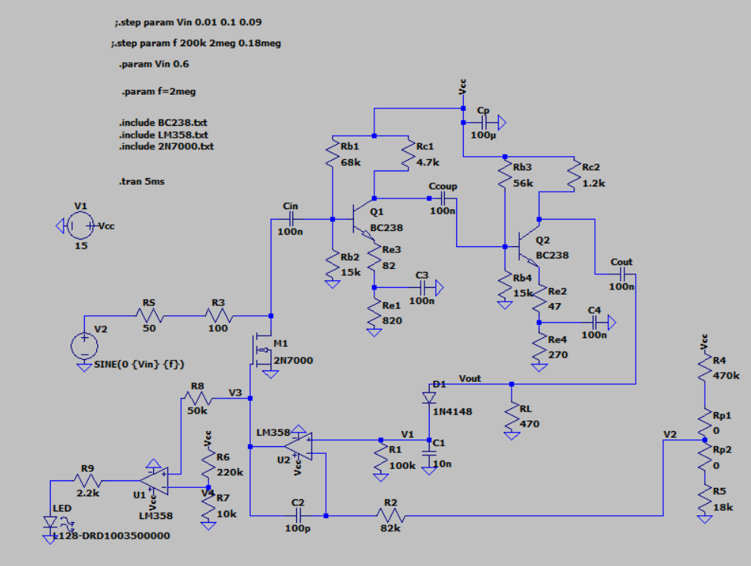
Figure 1: Photo of the circuit.
Specification 1:
The peak output voltage is Voutp=1±0.1 V undistorted sinusoidal when the peak input voltage is between Vinp=0.01 V and 0.1 V while the frequency is between 200KHz and 2MHz.
Input=200kHz and 0.01V
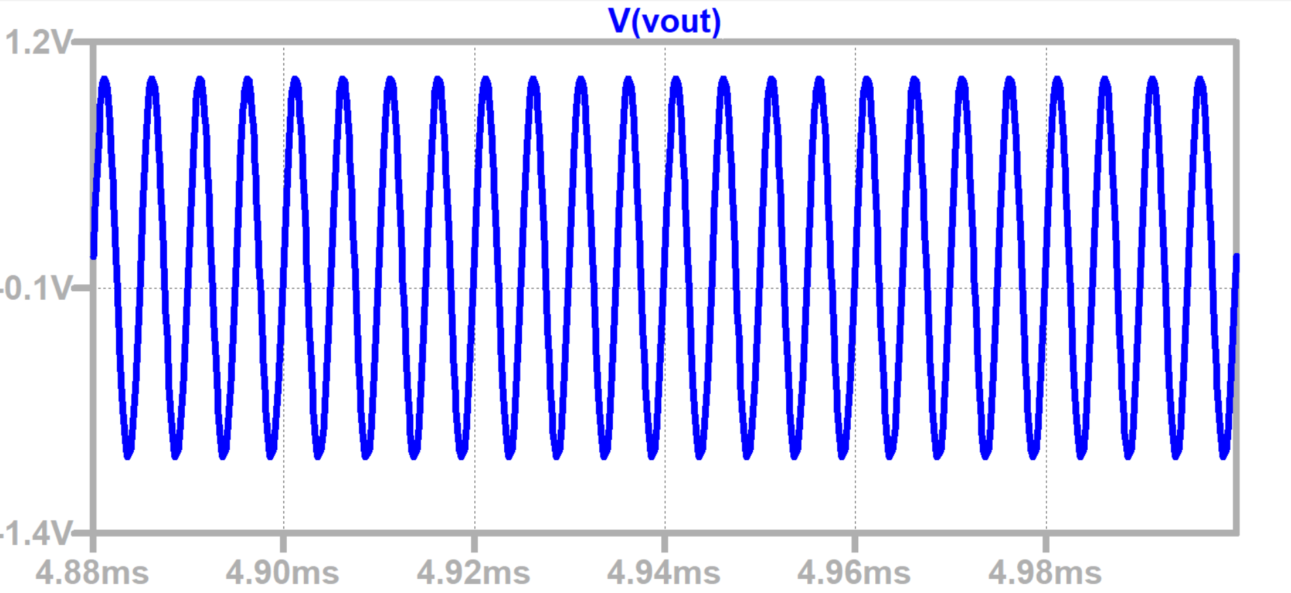
Figure 2: Vout for Input=200kHz and 0.01V

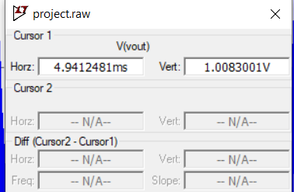
Figure 3: Value of Vout
Input=200kHz and 0.1V
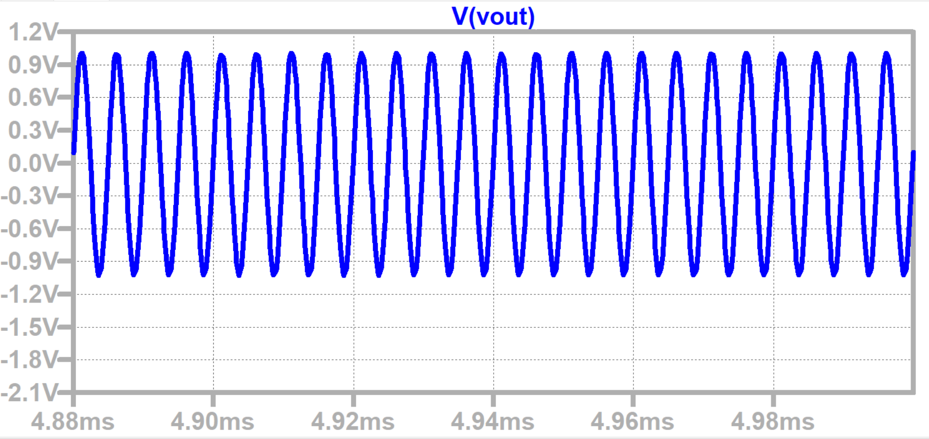
Figure 4: Vout for Input=200kHz and 0.1V
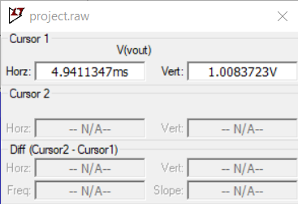
Figure 5: Vout Value
Input=2megaHz and 0.01V
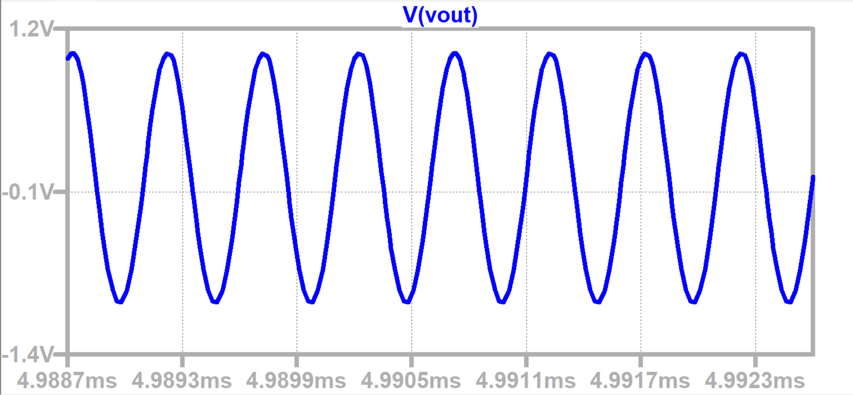
Figure 6: Vout for Input=2megaHz and 0.01V
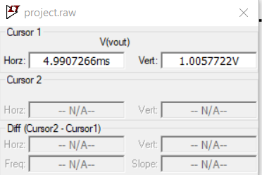
Figure 7: Vout value
Input=2megaHz and 0.1V
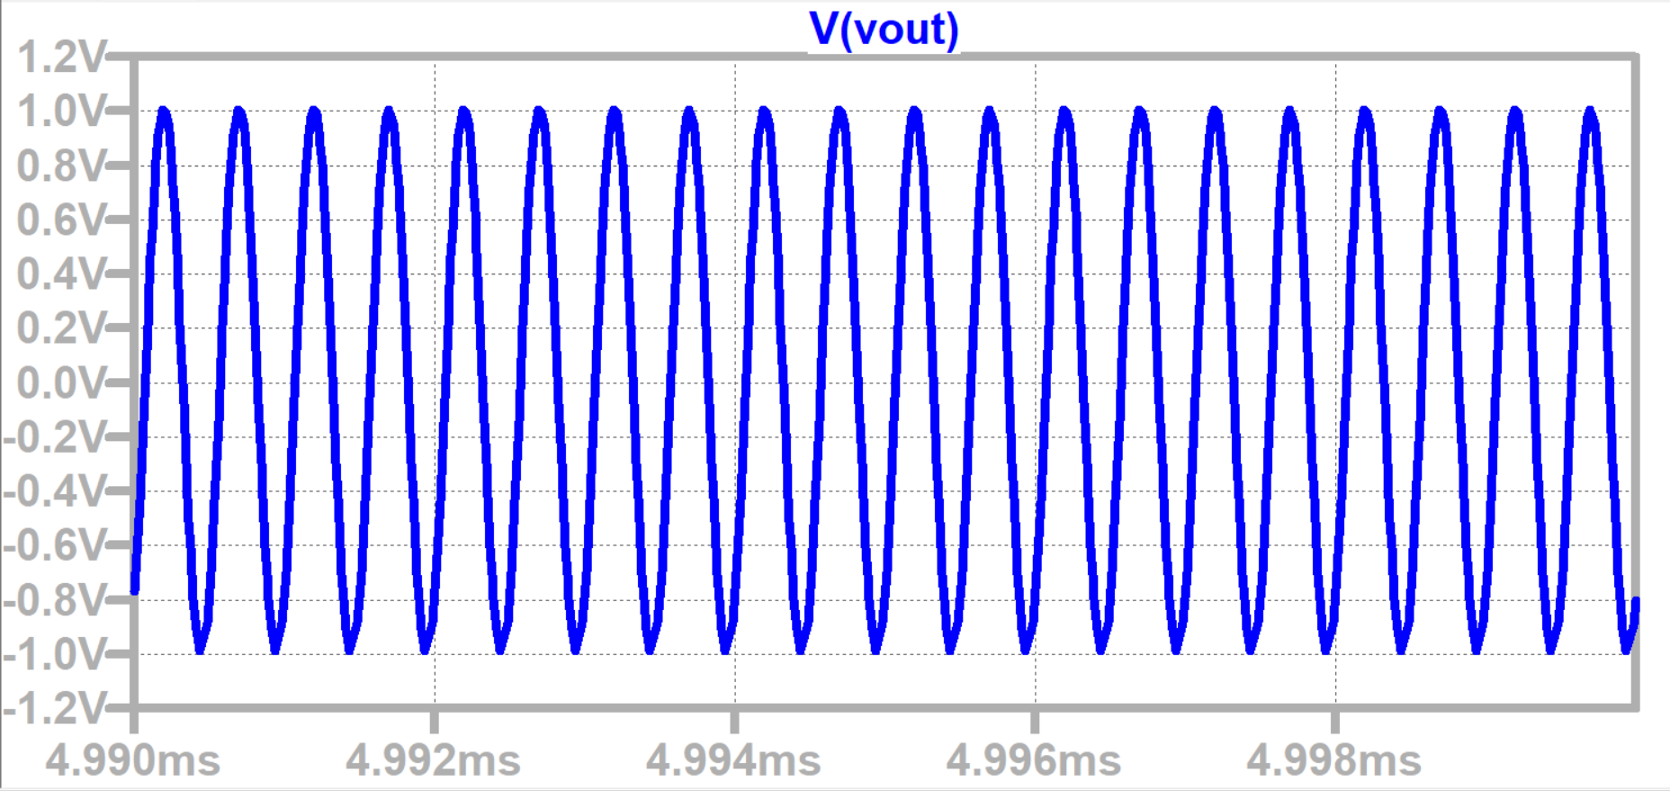
Figure 8: Vout for Input=2megaHz and 0.1V
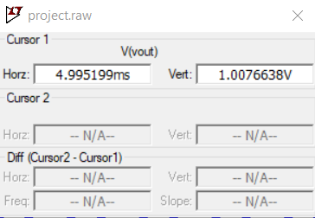
Figure 9: Vout value
As seen, Vout is between 0.9V and 1.1V, so it holds.
Specification 2:
The power supply current, ICC, is less than 100mA.

Input=200kHz and 0.1V
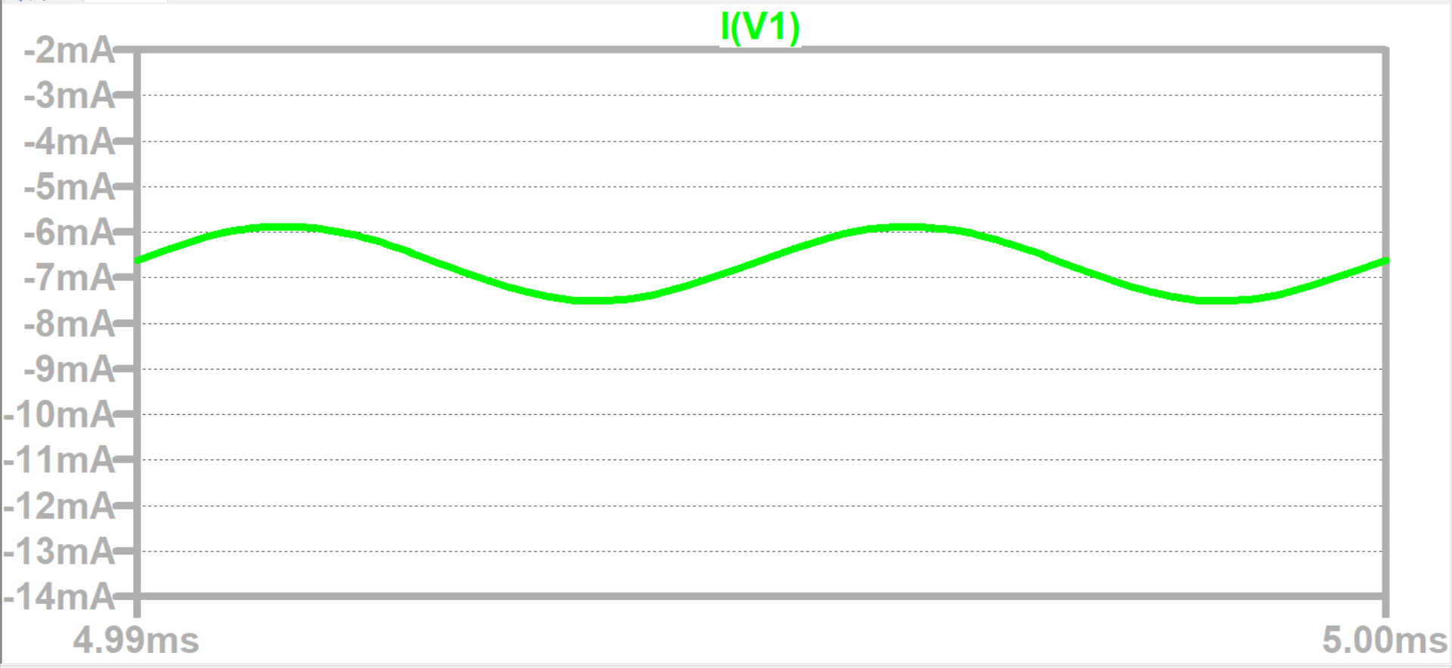
Figure 10: Icc for Input=200kHz and 0.1V
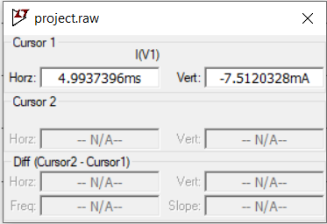
Figure 11: Icc value

Input=200kHz and 0.01V
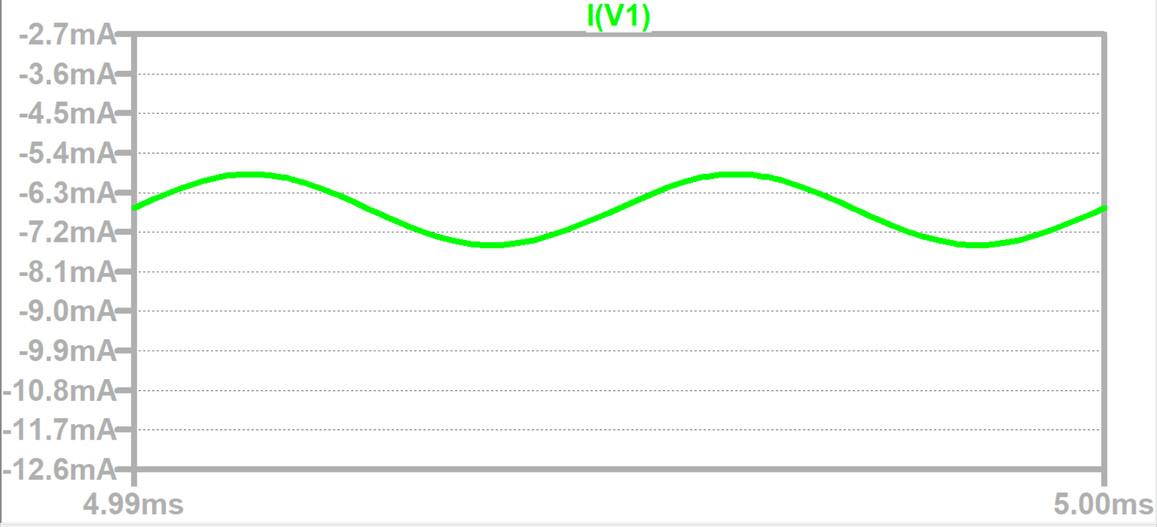
Figure 12: Icc for Input=200kHz and 0.01V
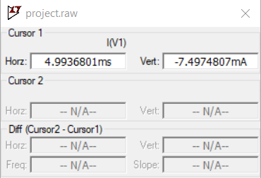
Figure 13: Icc value

Input=2megaHz and 0.1V
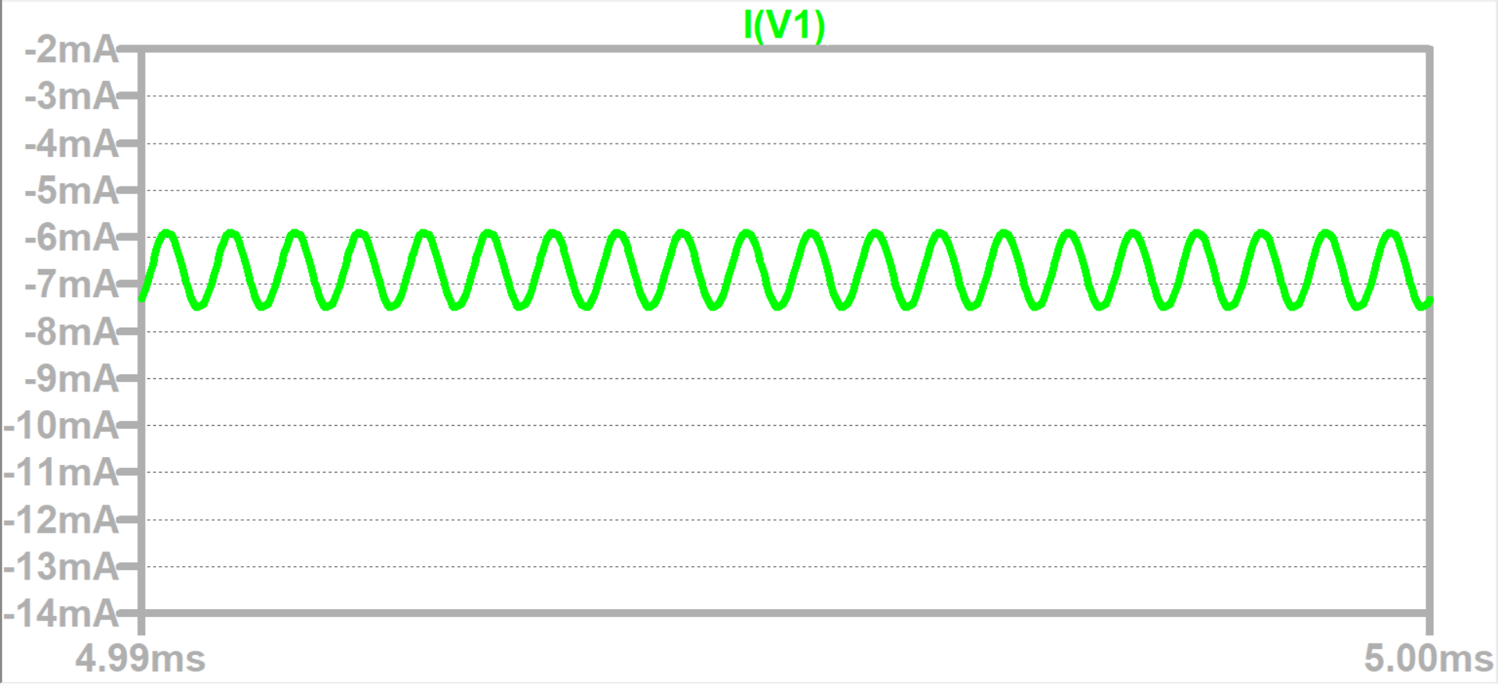
Figure 14: Icc for Input=2megaHz and 0.1V
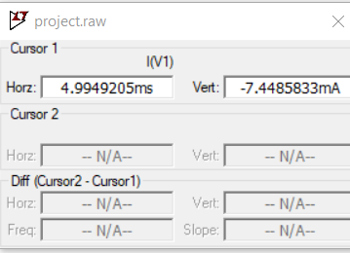
Figure 15: Icc value

Input=2megaHz and 0.01V
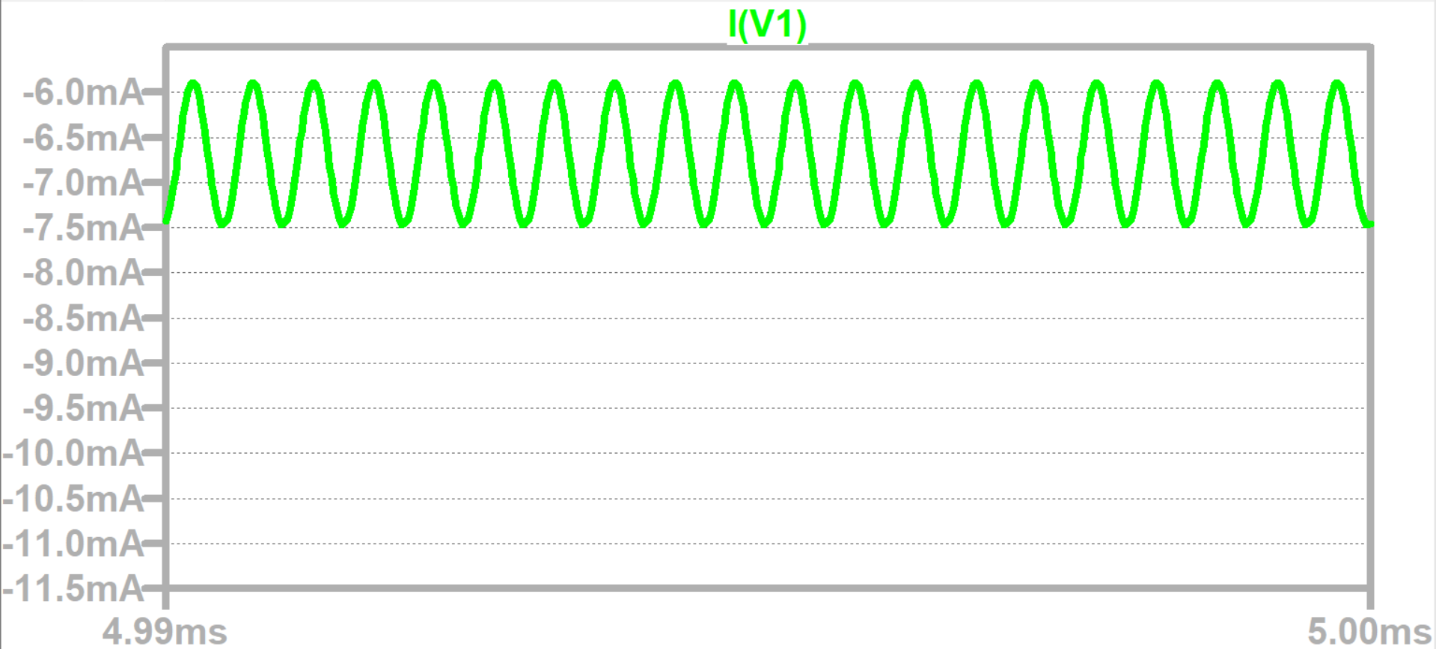
Figure 16: Icc value for Input=2megaHz and 0.01V
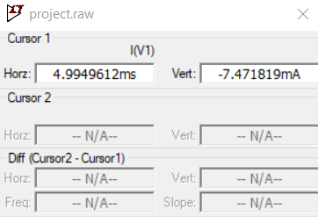
Figure 17: Icc value
As seen Icc is less then 100 mA so it holds.
Specification 3:
LED turns ON when the peak output voltage is Voutp=1±0.1 V. It should turn off if the peak output is less than Voutp< 0.9 V.

Vout is in range and Led is ON

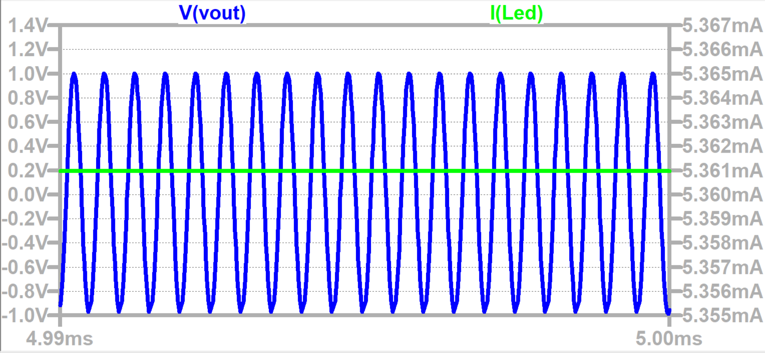
Figure 18: Vout in range and LED is ON
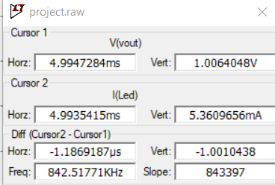
Figure 19: Values of Vout and LED

Vout is not in range and Led is OFF
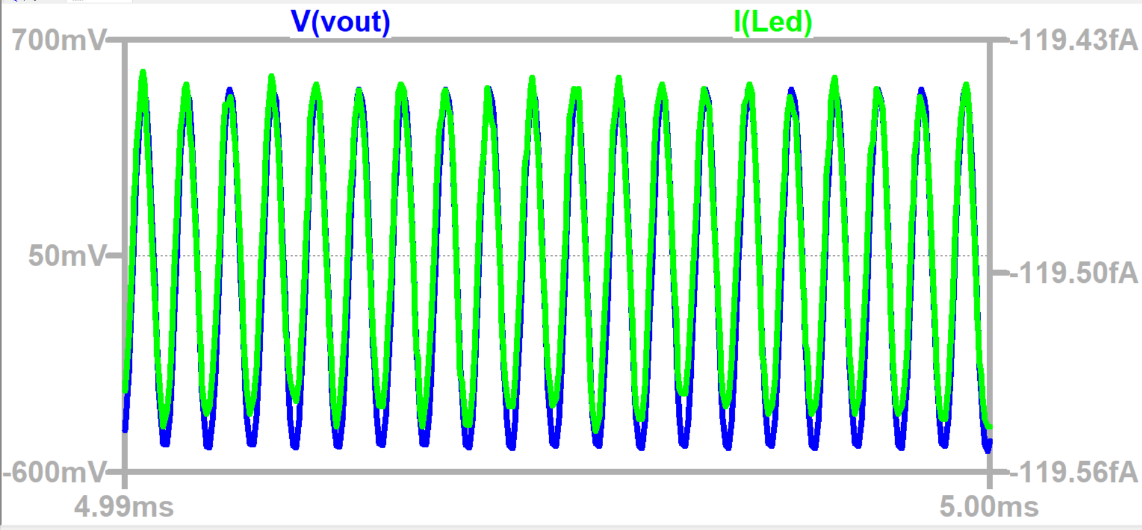
Figure 20: Vout is not in range and Led is OFF
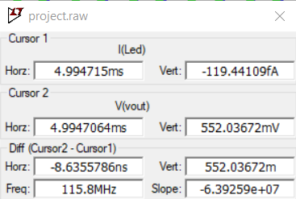
Figure 21: Values for Vout and LED
Specification holds.

TABLE
 | Vinp(mV) | Voutp(V) | LED ON/OFF | Icc(mA)
0.2MHz | 10 | 1.008 | ON | 7.5
0.2MHz | Vinpmin=6 | 1+-0.1 | ON | 7.5
0.2MHz | 100 | 1.008 | ON | 7.5
0.2MHz | Vinpmax=400 | 1+-0.1 | ON | 7.4
2MHz | 10 | 1.006 | ON | 7.5
2MHz | Vinpmin=10 | 1+-0.1 | ON | 7.5
2MHz | 100 | 1.008 | ON | 7.4
2MHz | Vinpmax=600 | 1+-0.1 | ON | 7.5

